Roden/Zevenhuizen
De crash van de Havilland Mosquito RV 326
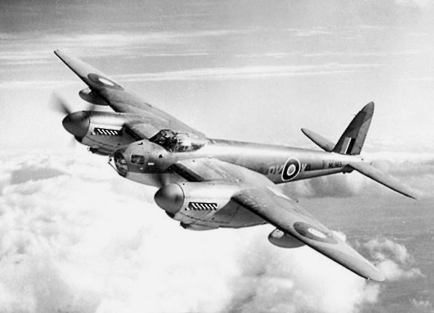

Een bombardements-missie naar Berlijn, met fatale afloop
27 maart 1945

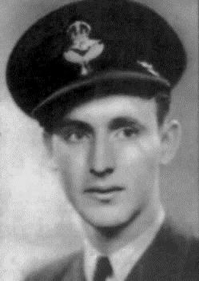

Tjerk Karsijns
First page; title of the book about the crash of the Mosquito RV 326.
On the pictures; Left Gordon Hudson, Right Maurice Gant.
The book has about 100 pages, with in it several explanations of witnesses.
I would love to get in contact with people who can tell me more.
Tjerk Karsijns., Roden, Netherlands.

In the evening of Tuesday March 27 1945, about 20.00 hours, two Havilland Mosquitoes collided in the neighbourhood of the village Zevenhuizen, in the Province Groningen. The aircraft that was responsible for the accident was the Mosquito MM 202, flown by pilot Leicester Georg Smith and navigator William Lane. Smith was born in New-Zealand, Lane in England. The Mosquito of Smith and Lane got in an air-pocket and fell down several meters. With the right engine the aircraft hit the left wing of the Mosquito RV 326, flown by David Gordon Hudson and Maurice George Gant. Hudson was born in New-Zealand, Gant in Canada.
Both aircraft were heavely damaged, but the MM 202 could return to England.
Both aircraft carried a 4000 lb. blockbuster Cookie bomb. (1850 kg.) The MM 202 lost its propellers, which were found in the municipality Peize, close to the boarder with Roden.
The MM 202 threw its bomb off above the coast of the Netherlands.
The RV 326 of Hudson and Gant flew over Roderesch/Alteveer in the direction Peize. There it made a curve and went to Roden, the village I (Tjerk Karsijns) live. Over Roden the RV326 threw off the droptank and the Cookie. Then it went to Nieuw-Roden, close to Roden. There the RV 326 dropped the dinghy. Over Roden the plane was already in flames.
Then it went in the direction of Zevenhuizen, the place where the collission was. Still burning the aircraf lost several parts. It made a curve in the direction of Haulerwijk and made another curve in the direction of Roden. There it lost the engine and the propellers. (must be the left engine) In a field in the neighbourhood of the boarder of the provinces Groningen and Drenthe the propellers and the engine came down. It was in the municipality Roden. I have spoken two 87-year old ladies, who were on the crashplace the day after. They were 15 years old in those days.
After the aircraft had lost the engine it definatily crashed about 400 meters later. It came down in a cornfield. Afterwards on that place the remains of the crew were put in one coffin, and buried in Zevenhuizen.

In the morning of March 28 1945, a day after the crash, the young girls went to the first crash-place; there was a hole in the ground. A German soldier guarded the place. The girls were shocked; they found a boot of one of the crewmembers, with in it human remains. The girls ran away.
What has happened? I think that the wooden aircraft, burning so long, lost the engine because of that. Probably the engine was still running. When it broke off the plane maybe the propellers hit the cockpit, destroyed the perspex of the cockpit, and cut off the underleg of the pilot. The rest of the plane came down about 400 meters later. Many parts of the plane were found there.

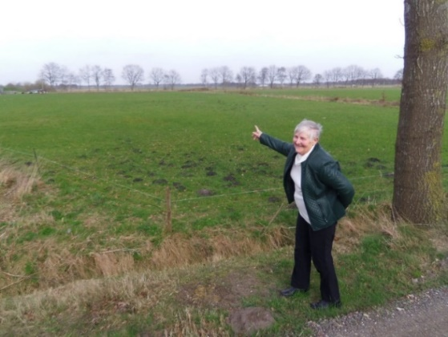

First crash-place, where the engine and propellers came down.
87-year old Maike Stuut-Van Wijk, pointing to the place the hole was in the ground.
RV 326 Mosquito.

