About 400 meters from the place where the engine fell off.
Second crash-place. Here the rest of the aircraft was found, in a ditch. After the war one engine was found here.
RV 326 Mosquito

In front of this farmhouse the propellers of the MM 202 Mosquito were found. (Municipality Peize)

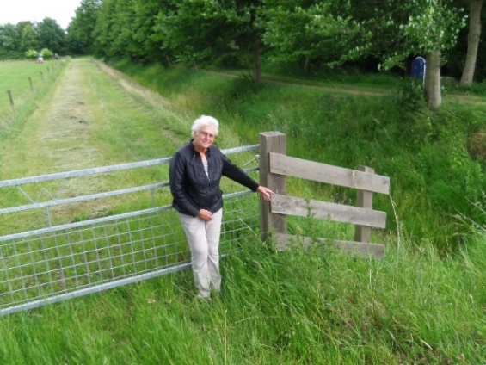

Grietje Blaauwwiekel-Van Lingen, poiting to the place the propellers were found. (before the farmhouse)
MM 202
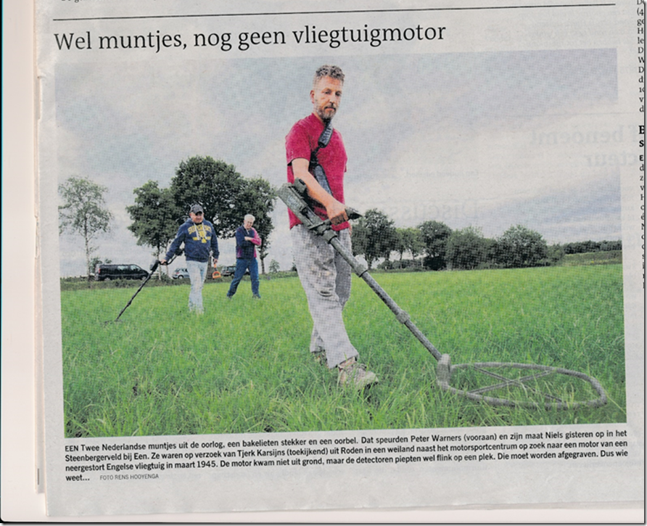
This picture was in the newspaper on July 5 2017.
Searching for the propellers and Engine of the Mosquito RV 326.
Two spots were found, exactly on the place the 87-year old lady told us.

