Dave, below what I forgot to send.
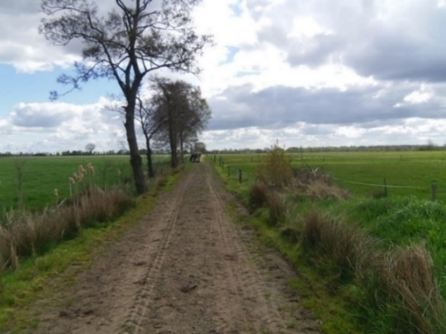

Place the rest of the aircraft crashed (second crash-place)
It is about 400 meters from the first place. (where an engine and propeller fell down) After the war here one engine was digged up.

In front of this farmhouse the propellers of the MM 202 Mosquito were found. (Municipality Peize)

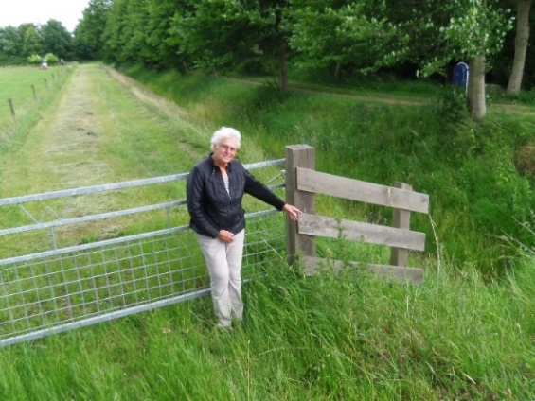

Grietje Blaauwwiekel-Van Lingen, poiting to the place the propellers were found. (before the farmhouse)
MM 202
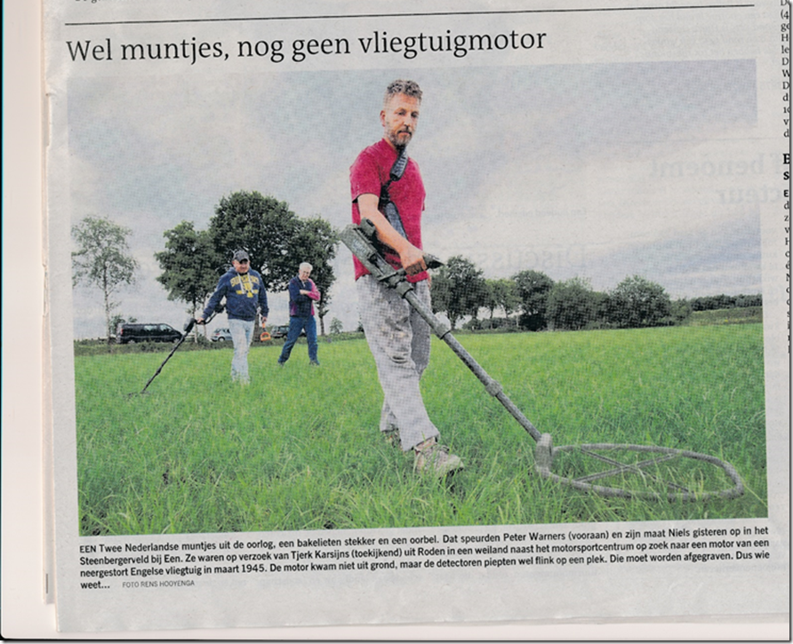
This picture was in the newspaper on July 5 2017.
Searching for the propellers and Engine of the Mosquito RV 326.
Two spots were found, exactly on the place the 87-year old lady told us.

